**Chapter 6:**

Box Model:

Content - Text & web page elements in the container.

Padding - Area between the content and the border.

Border - Between the padding and the margin

Margin - Determines the empty space between the element and adjacent elements.

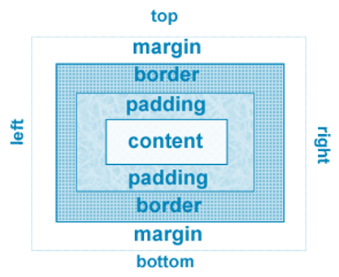

Configure Margin with CSS:

The margin property.

Related properties: margin-top, margin-right, margin-left, margin-bottom.

Configures empty space between the element and adjacent elements

Syntax examples

h1 { margin: 0; }

h1 { margin: 20px 10px; }

h1 { margin: 10px 30px 20px; }

h1 { margin: 20px 30px 0 30px; }

Configure Padding with CSS:

The padding property

Related properties: padding-top, padding-right, padding-left,   
padding-bottom.

Configures empty space between the content of the HTML element (such as text) and the border.

Syntax examples

h1 { padding: 0; }

h1 { padding : 20px 10px; }

h1 { padding : 10px 30px 20px; }

h1 { padding : 20px 30px 0 30px; }

Box Model in Action:

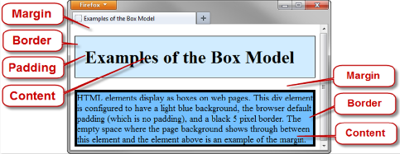

The CSS box-sizing Property:

Default value for width or height is the value for ONLY the content (not including border and padding).

The box-sizing property is used to selector to direct the browser to calculate the width and height of an element to include the value for content, padding, and border.

Use the universal selector (*) to apply this to all the element on the page

Example:

* { box-sizing: border-box; }

Normal Flow:

Browser display of elements in the order they are coded in the web page document.

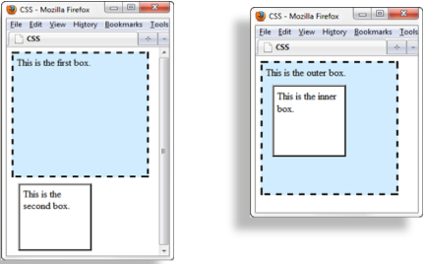

Float Property:

Elements that seem to “float" on the right or left side of either the browser window or another element are often configured using the float property.

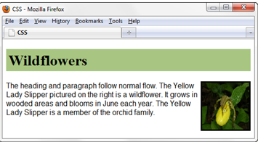

h1 { background-color:#cccccc;

padding:5px;

color: #000000 }

p { font-family:Arial,sans-serif; }

#yls {float:right;

margin: 0 0 5px 5px;

border: 1px solid #000000; }

clear Property:

Useful to “clear” or terminate a float.

Values are left, right, and both.

Overflow Property:

Intended to configure the display of elements on a Web page.

However, it is useful to “clear” or terminate a float before the end of a container element.

Values are auto, hidden, and scroll.

CSS display Property:

Configures how and if an element is displayed:

**display: none -** The element will not be displayed.

**display: block -** The element is rendered as a block element – even if it is actually an inline element, such as a hyperlink.

**display: inline -** The element will be rendered as an inline element – even if it is actually a block element – such as a <li>.

**display: inline-block -** The element will display as an inline display element adjacent to other inline display elements but also can be configured with properties of block display elements including width and height.

Basic 2-Column Layout:

<body>

<div id="wrapper">

<header> <header>

<nav> </nav>

<main> </main>

<footer> </footer>

</div>

</body>

#wrapper { width: 80%; margin-left: auto; margin-right: auto; background-color: #EAEAEA; }

header { background-color: #CCCCFF; }

h1 { margin: 0; padding: 10px; }

nav { float: left; width: 90px; padding: 10px; }

main { margin-left: 100px; padding: 10px; background-color: #FFFFFF; }

footer { text-align: center; font-style: italic; background-color: #CCCCFF; }

Vertical Navigation:

<nav>

<ul>

<li><a href="index.html">Home</a></li>

<li><a href="menu.html">Menu</a></li>

<li><a href="directions.html">Directions</a></li>

<li><a href="contact.html">Contact</a></li>

</ul>

</nav>

CSS removes the list marker and underline:

nav ul { list-style-type: none; }

nav a { text-decoration: none; }

Horizontal Navigation:

<nav>

<ul>

<li><a href="index.html">Home</a></li>

<li><a href="menu.html">Menu</a></li>

<li><a href="directions.html">Directions</a></li>

<li><a href="contact.html">Contact</a></li>

</ul>

</nav>

CSS removes the list marker, removes the underline,   
adds padding, and configures the list items for inline display.

nav ul { list-style-type: none;}

nav a { text-decoration: none; padding-right: 10px; }

nav li { display: inline; }

CSS Pseudo-classes:

Pseudo-classes and the anchor element.

**link** – default state for a hyperlink .

**visited** – a hyperlink that has been visited.

**focus** – triggered when the hyperlink has focus.

**hover** – triggered when the mouse moves over the hyperlink.

**active** – triggered when the hyperlink is being clicked.

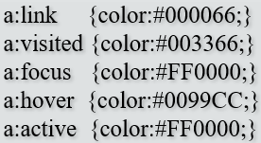

Header Text Image Replacement:

Useful when a non-web-safe font must be used in the header logo banner area.

Display the banner image but also configure text in the h1 for use by search engines and assistive technologies.

Configure styles for the header element set the header banner image as the background of the header or h1 element.

Code the company or website name with the h1 element.

Configure the placement of the h1 text to be beyond the browser viewport:

h1 { text-indent: 100%; white-space: nowrap; overflow: hidden;}

Position Property:

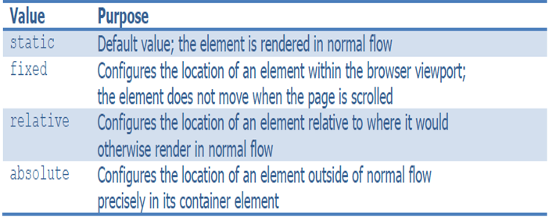

Fixed Positioning:

Nav { position: fixed; }

Relative Positioning:

Changes the location of an element in relation to where it would otherwise appear in normal flow.

p { position: relative;

left: 30px;

font-family: Arial, sans-serif; }

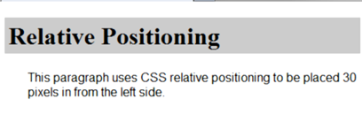

Absolute Positioning:

Precisely specifies the location of an element outside of normal flow

in in relation to its first parent non-static element.

p { position: absolute;

left: 200px;

top: 100px;

font-family: Arial, sans-serif;

width: 300px; }

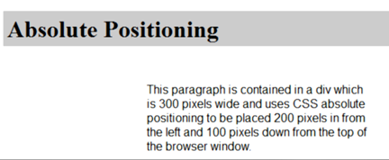

CSS Debugging Tips;

Manually check syntax errors.

Configure temporary background colors.

Configure temporary borders.

Use CSS comments to find the unexpected.

/* the browser ignores this code */

Don’t expect your pages to look exactly the same in all browsers!

Be patient!

HTML5 Structural Elements REVIEW:

**Header Element** - block display; contains the headings of either a web page document or an area in the document such as a section or article.

**Nav Element** - block display; contains a section of navigation hyperlinks.

**Main Element** - block display; contains main page content.

**Footer Element** - block display; contains the footer content of a web page or specific area (such as a section or article) on a web page.

More HTML5 Elements:

**Aside Element** - block display; contains a sidebar, a note, or other tangential content.

**Section Element** - contains a “section” of a document, such as a chapter or topic block display.

**Article Element** - contains an independent entry, such as a blog posting, comment, or e-zine article that could stand on its own.

block display

**Time Element**: represents a date or a time, could be useful to date articles   
or blog posts, inline display.

HTML5 Compatibility with Older Browser:

CSS: header, main, nav, footer, section, article,   
 figure, figcaption, aside; { display: block; }

HTML5 Shim (aka HTML5 Shiv): <!--[if lt IE 9]>

<script src=" http://html5shim.googlecode.com/svn/trunk/html5.js"> </script>

<![endif]-->

Decide to Configure a class or id:

Configure a class:

If the style may apply to more than one element on a page

Use the . (dot) notation in the style sheet.

Use the class attribute in the HTML.

Configure an id:

If the style is specific to only one element on a page

Use the # notation in the style sheet.

Use the id attribute in the HTML.